Project Planning Phase
Project Planning Template (Product Backlog, Sprint Planning, Stories, Story points)

Date | 20 October 2026
Team ID | Niharika Suhane
Project Name | IMovies - Movie ticket booking made simple.
Maximum Marks | 4 Marks

IMovies – Product Backlog, Sprint Schedule, and Estimation (4 Marks)
The following product backlog is customized for IMovies – Movie Ticket Booking Made Simple, covering user authentication, movie browsing, seat selection, ticket booking, payments, and reviews across four sprints.

1. Product Backlog & Sprint Schedule
Sprint | Functional Requirement (Epic) | User Story No. | User Story / Task | Story Points | Priority
Sprint 1 | User Authentication | USN-1 | As a user, I can sign up and log in securely. | 3 | High
Sprint 1 | User Authentication | USN-2 | As a user, I can reset my password. | 2 | Medium
Sprint 1 | Movie Browsing | USN-3 | As a user, I can browse and search movies. | 3 | High
Sprint 2 | Movie & Showtime Management | USN-4 | As a user, I can view movie details, theatres, and showtimes. | 3 | High
Sprint 2 | Movie & Showtime Management | USN-5 | As a user, I can filter movies by language, genre, and location. | 2 | Medium
Sprint 2 | Seat Selection | USN-6 | As a user, I can view seat availability and select seats. | 5 | High
Sprint 3 | Ticket Booking | USN-7 | As a user, I can book tickets and receive booking confirmation. | 5 | High
Sprint 3 | Payment Integration | USN-8 | As a user, I can pay securely for movie tickets. | 5 | High
Sprint 3 | Digital Tickets | USN-9 | As a user, I can view and download my digital ticket. | 3 | Medium
Sprint 4 | Booking Management | USN-10 | As a user, I can view my booking history. | 2 | High
Sprint 4 | Notifications | USN-11 | As a user, I can receive booking and payment notifications. | 2 | Medium
Sprint 4 | Reviews & Ratings | USN-12 | As a user, I can rate and review a movie after watching it. | 3 | Medium

Note: Story points are estimated effort values, not hours. Team members can be assigned according to the actual project team.

2. Project Tracker, Velocity & Sprint Release Schedule
The following schedule uses six days per sprint. The dates and completion values are illustrative and can be updated based on actual project progress.
Sprint | Total Story Points | Duration | Sprint Start Date | Planned End Date | Points Completed | Release Date
Sprint 1 | 8 | 6 Days | 1 May 2025 | 6 May 2025 | 8 | 6 May 2025
Sprint 2 | 10 | 6 Days | 7 May 2025 | 12 May 2025 | 10 | 12 May 2025
Sprint 3 | 13 | 6 Days | 13 May 2025 | 18 May 2025 | 13 | 18 May 2025
Sprint 4 | 7 | 6 Days | 19 May 2025 | 24 May 2025 | 7 | 24 May 2025
Total | 38 | 24 Days | — | — | 38 | —

3. Sprint Velocity
Velocity is the number of story points completed by the team in each sprint.
IMovies Sprint Velocity
Illustrative completed story points per sprint.
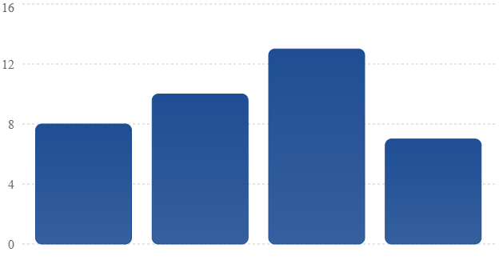
- Total story points: 38
- Average sprint velocity: 9.5 story points
- Total planned duration: 24 days

4. Burndown Chart — Sprint 1
The burndown chart tracks the remaining work during Sprint 1, starting with 8 story points and ideally reaching zero by the end of the sprint.
Sprint 1 Burndown Chart
Ideal remaining story points across six days.
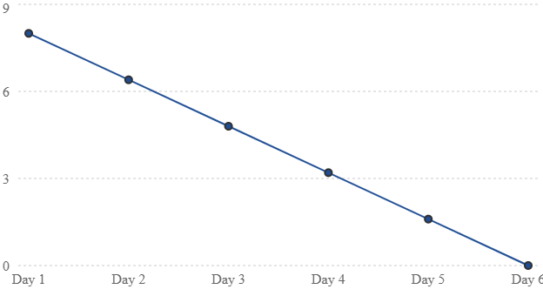

Conclusion: The IMovies product backlog divides development into four sprints, progressing from authentication and movie discovery to seat selection, secure payments, digital tickets, and reviews. Sprint velocity and burndown tracking help monitor progress and deliver a reliable movie ticket booking platform.

\

